# Final project (max 4 points)

(individual or 2-person teams)

Choose a business process - it can be a process in any company or organization known to you, it can be a process based on one of the tasks done during the tutorials. Using appropriate tools create (max 1.5 points):

* a text description of the current business process,
  + current
    - The process begins when customer orders something. Then sales department verifies the order. If the order is not valid the proposal of valid order is made and sent to the customer and the process ends. If the order is valid the sales department simultaneously prepares and sends an offer to the customer and check the availability of the ordered products. If the customer makes a counter offer the sales department checks if the offer is still beneficial for the company. If it is then the process continues, if it’s not then the message is sent to the customer that only the previous offer is valid. When the customer accepts the offer the company waits a week for the customer to pay. If the customer paid the sales department based on previous analysis sends an order to Warehouse or Production department to make more of certain products. Warehouse and Production make use of archives where all of the information is stored (about the products in the Warehouse as well as the projects for production). If the products are "ready", they are send to the QualityAssurance department to check the condition of produced / stored products. If all of the products are ok the process continues, If not Warehouse and Production departments are notified that the products need to be delivered to QualityAssurance as soon as possible. If that happens the qulaity of the product is checked again. If the products are ready and their quality is satisfying the shipping department is notified that they can ship the merchandise to the customer and also customer is notified that the products will be soon delivered. Process ends when the shipping plan is made then all of the products are prepared and at the end the product is safely shipped to the customer.
  + Automated
    - The process begins when customer orders something. Then sales departments verifies the order. If the order is not valid the proposal of a valid order is made and saved to the db and sent to the customer. If the order is valid it’s saved in the db, the sales dept simultaneously prepares and sends an offer to the customer and check the availability of of the ordered product in a stored products catalogue. If the customer makes a counter offer it’s saved to the db, the sales department sends a query to bid and proposal dept to find out whether the offer is still beneficial to the company. Bid and proposal dept performs analysis which result is saved in the db. The bid and proposal dept sends the analysis result to the sales dept based on which the decision is made whether the process can be continued or the customer must be informed that only the previous offer is valid. If the customers accepts the offer the company waits a week for the customer to pay. If the customer paid, the sales department based on previous analysis and db query sends an order to Warahouse or Prduction dept to make more of certain products. If the products are “ready", they are send to the QualityAssurance department to check the condition of produced / stored products. The result of quality check is saved to the db. If all of the products are ok, the process continues, If not Warehouse and Production departments are notified that the products need to be delivered to QualityAssurance as soon as possible. If that happens the qulaity of the product is checked again. If the products are ready and their quality is satisfying the shipping department is notified that they can ship the merchandise to the customer and also customer is notified that the products will be soon delivered. Process ends when the shipping plan is made then all of the products are prepared and at the end the product is safely shipped to the customer.
* 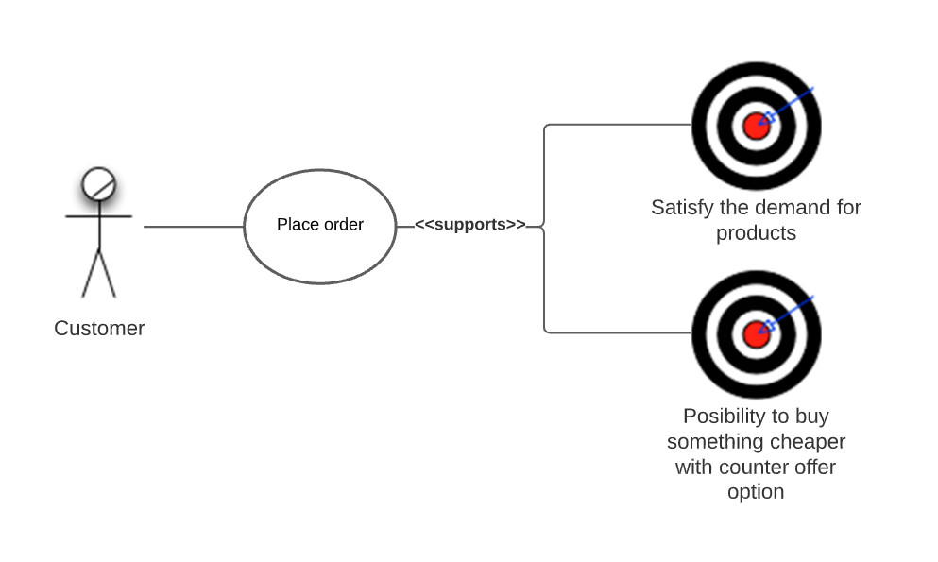business use case diagram for this process,
* 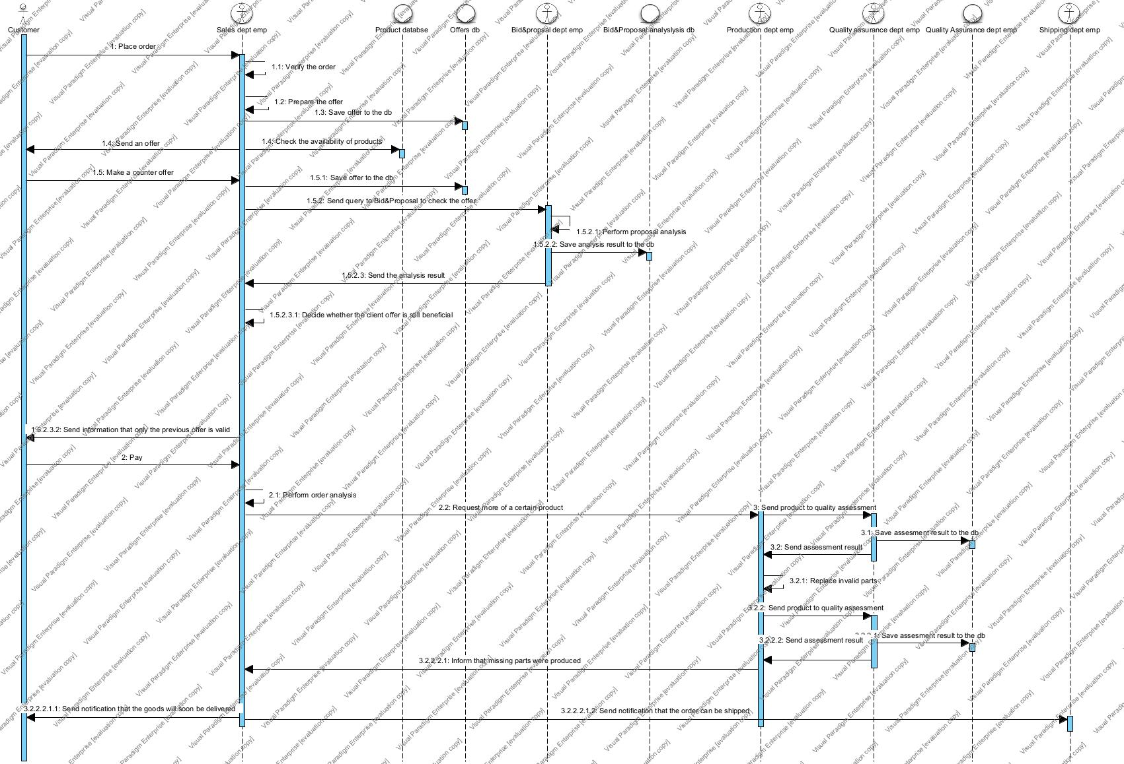business analysis diagram for this process,
* BPMN diagram with the current form of this business process. Remember about modelling unusual situations, error handling etc.

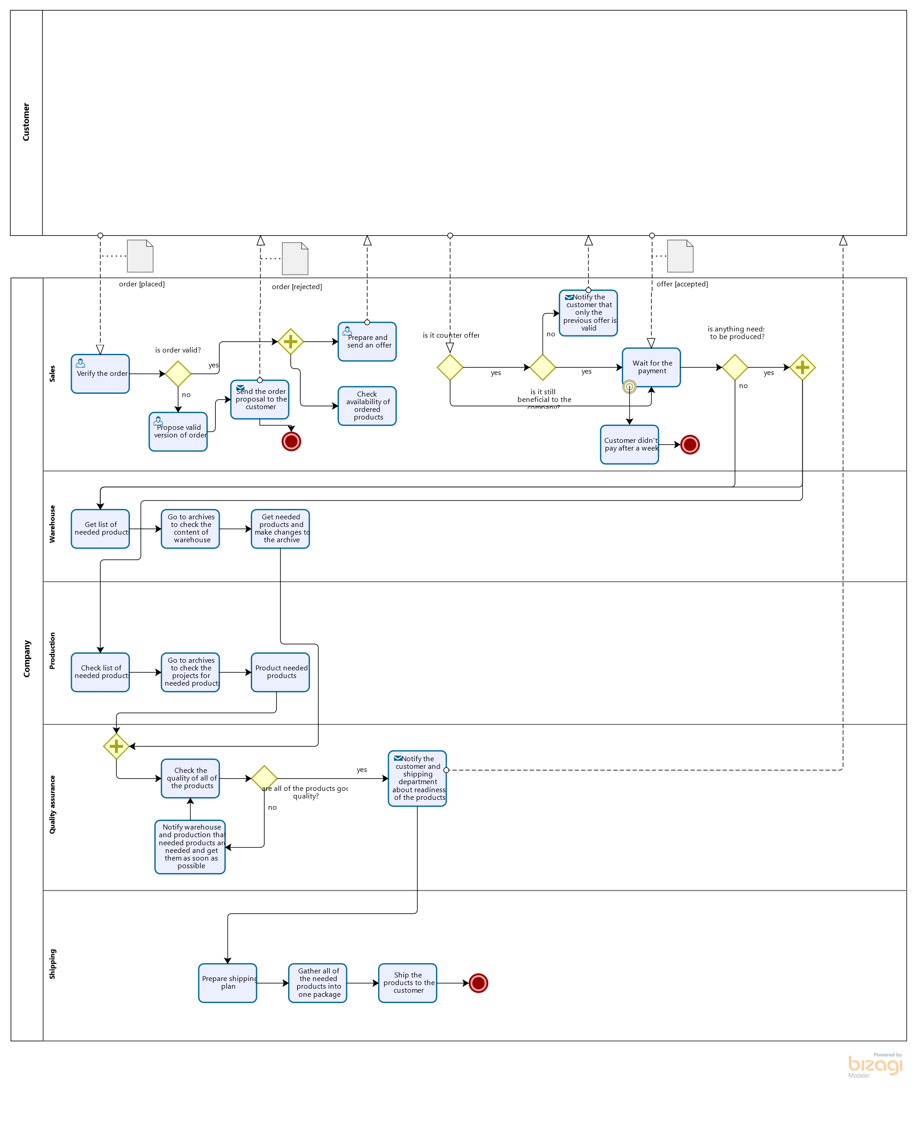

Based on this design a new version of the business process, assuming utilization of IT tools to support this process - automation of activities that can be automated etc. Prepare (max 1.5 points):

* 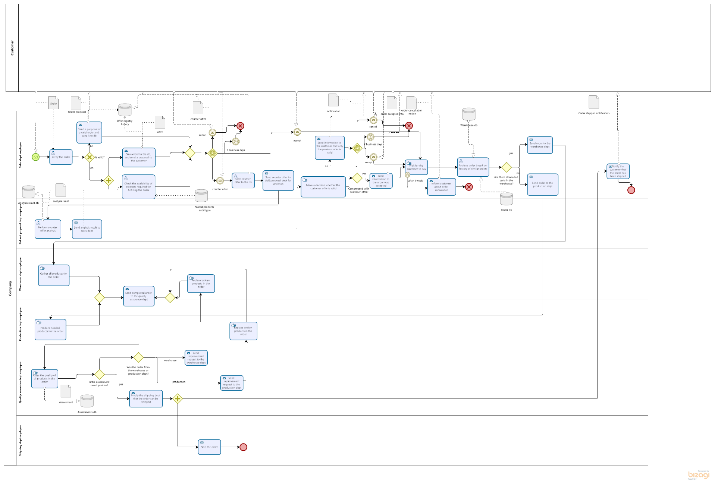BPMN diagram showing the new form of the business process,
* 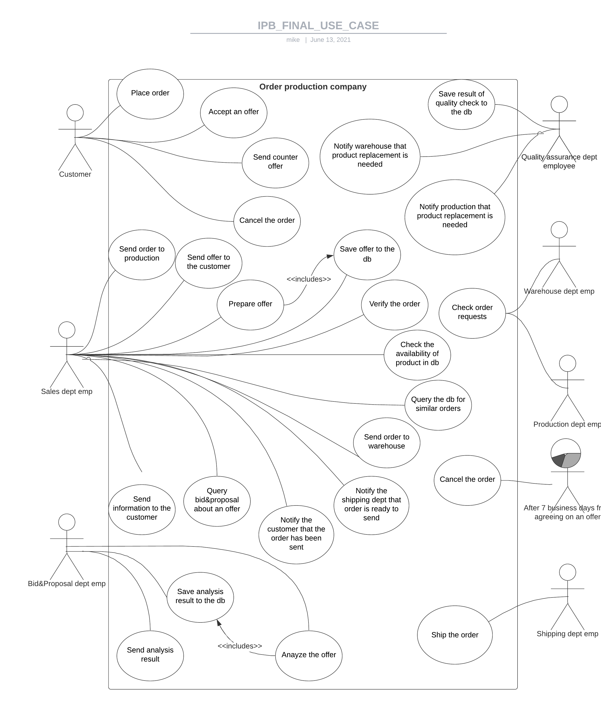Use case diagram (regular, not business) for this business process,
* 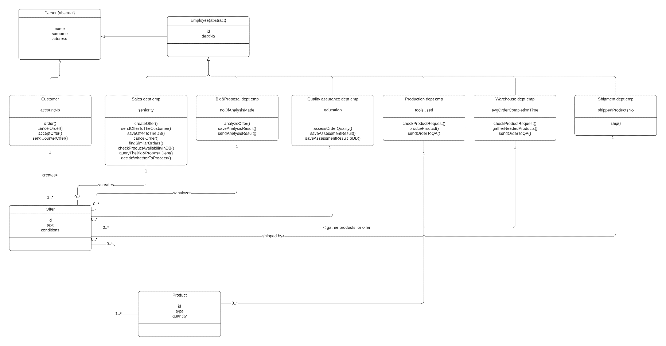Class or entity diagram, modeling the data which will be processed in this business process,

Prepare a prototype of application supporting the process (max 1 point)

* Prototype of application supporting the business process – does not have to be fully functional, or use database – but has to allow us to navigate and see the UI for all tasks in the process
  + [JanCieslak/ibp-project (github.com)](https://github.com/JanCieslak/ibp-project)

The process in its final form should have at least 12 activities in the case of individual projects, 20 in the case of group projects. Not all activities have to be a part of the “main” scenario of this process - this number includes also alternate activities, handling errors and unusual situations etc.